

**Product Dissection for Instagram**

### **Company Overview:**

Instagram, founded in 2010 by Kevin Systrom and Mike Krieger, has transformed the way people interact, share, and explore visual content online. Acquired by Facebook, Instagram has become a global social media phenomenon, known for its captivating interface and innovative features. With a focus on visual storytelling and user engagement, Instagram has attracted millions of users worldwide, making it one of the leading platforms in the social networking landscape.

### **Product Dissection and Real-World Problems Solved by Instagram:**

Instagram, a global social media phenomenon, has effectively addressed real-world challenges through its innovative product offerings. With a focus on visual storytelling, Instagram empowers users to authentically share their experiences and passions, bridging the gap between digital interactions and genuine connections. By allowing users to share photos and videos accompanied by captions, locations, and hashtags, Instagram provides a solution to the need for meaningful expression and engagement. This core feature solves the problem of connecting in an increasingly digital world, enabling users to form genuine relationships and engage in conversations that transcend geographical boundaries.

Instagram's ingenious engagement features, such as likes, comments, and personalised content recommendations through the "Explore" feature, have revolutionised how users interact with content. By addressing the challenge of content overload, Instagram curates relevant content, helping users discover new accounts, posts, and trends tailored to their interests. Furthermore, Instagram's introduction of hashtags has transformed content discovery by allowing users to categorise their posts with keywords. This innovative approach effectively addresses the challenge of navigating through a sea of content to find relevant information, making it easier for users to connect with content aligned with their interests and engage in conversations that matter to them.

In conclusion, Instagram's product design has successfully tackled real-world problems by creating a platform that nurtures creativity, fosters connections, and offers a space for self-expression. Through its diverse features, Instagram addresses the need for authentic engagement, content curation, and meaningful discovery, shaping the digital landscape and providing practical solutions to the evolving needs of its global user base.

### **Case Study: Real-World Problems and Instagram's Innovative Solutions**

Instagram, a leading social media platform, has not only revolutionised the way we share and consume content but has also addressed significant real-world challenges through its innovative features. By identifying user needs and leveraging technology, Instagram has positioned itself as a solution-driven platform that fosters connections, encourages self-expression, and enhances digital interactions.

#### **Problem 1: Disconnect in Digital Relationships**

**Real-World Challenge:** As our lives become increasingly digital, the lack of genuine connections in online interactions has become a prevalent concern. Users often struggle to convey emotions and experiences effectively through text-based communication alone, leading to a disconnect in digital relationships.

**Instagram's Solution:**

Instagram recognized the need for authentic expression in digital interactions. By allowing users to share photos and videos alongside captions, locations, and hashtags, the platform creates a visually rich environment where users can share their lives more vividly. The power of visual storytelling bridges the gap between online interactions and real emotions, enabling users to connect on a deeper level. Through this approach, Instagram effectively tackles the problem of disconnection, nurturing meaningful relationships and promoting genuine interactions.

#### **Problem 2: Information Overload**

**Real-World Challenge:** The vast amount of content available online can overwhelm users, making it challenging to discover relevant and engaging content aligned with their interests.

**Instagram's Solution:**

Instagram addresses the issue of content overload through its innovative "Explore" feature. By leveraging advanced algorithms, the platform curates a personalised feed of content tailored to each user's preferences. This intelligent content recommendation system ensures that users encounter posts, accounts, and trends that resonate with their interests, mitigating the problem of information overload and enhancing the user experience.

#### **Problem 3: Finding a Niche for Creativity**

**Real-World Challenge:** Many individuals aspire to pursue creative endeavours, but finding a platform to showcase and monetize their talents can be daunting.

**Instagram's Solution:**

Instagram empowers creative individuals by providing a platform where they can showcase their talents, gain followers, and collaborate with brands. Influencers and content creators can turn their hobbies into viable careers, solving the problem of finding a niche for creativity and providing an avenue for personal and professional growth.

#### **Problem 4: Limited Personal Branding**

**Real-World Challenge:** Establishing a unique online identity can be challenging, as traditional text-based platforms often limit personal branding.

**Instagram's Solution:**

Instagram offers users a comprehensive profile space that includes a profile picture, username, bio, and highlights. This space allows users to express their personality and interests visually, solving the problem of limited personal branding on traditional platforms.

#### **Conclusion:**

Instagram's journey from a photo-sharing app to a global platform is a testament to its ability to identify real-world problems and provide innovative solutions. By fostering genuine connections, curating content, supporting creativity, and enabling personal branding, Instagram has addressed various challenges that users encounter in the digital landscape. This case study showcases how Instagram's user-centric approach and continuous innovation have positioned it as a leader in the social media domain, effectively shaping the way we engage and interact online.

### **Top Features of Instagram:**

1. **User Profiles:** Instagram allows users to create personal profiles, offering insights into their lives through features such as usernames, full names, bios, and profile pictures. This creates a personalised online presence that reflects each user's identity.
2. **Posts:** A core feature of Instagram is the ability to share photos and videos as posts. Users can add captions, tag locations, and enhance their content using filters, stickers, and other creative tools.
3. **Interactions**: Engagement lies at the heart of Instagram. Users can express appreciation by liking posts and sharing their thoughts through comments. The "Save" feature enables users to bookmark content for later viewing.
4. **Followers and Following:** The platform fosters connections through the "Follow" functionality. Users can follow other accounts to see their posts in their feed, creating a network of connections. Users can also view who is following them, enhancing transparency.
5. **Explore:** The "Explore" feature propels discovery by suggesting content based on user preferences and interactions. Users can explore posts, videos, and stories from accounts they don't follow, fostering a diverse online experience.
6. **Hashtags:** Instagram pioneered the use of hashtags, which categorise posts and enhance discoverability. Users can add relevant hashtags to their posts, making them accessible to a broader audience.

### **Schema Description:**

The schema for Instagram involves multiple entities that represent different aspects of the platform. These entities include Users, Posts, Comments, Likes, Followers, Hashtags, and more. Each entity has specific attributes that describe its properties and relationships with other entities.

**User Entity:**

Users are at the core of Instagram. The user entity contains information about each user:

* **UserID (Primary Key)**: A unique identifier for each user.
* **Username**: The chosen username for the user's account.
* **Email**: The user's email address for account-related communication.
* **Full_Name**: The user's full name as displayed on their profile.
* **Bio**: A brief description that users can use to express themselves.
* **Registration_Date**: The date when the user joined Instagram.

**Post Entity:**

Posts capture the visual content shared on the platform:

* **PostID (Primary Key):** A unique identifier for each post.
* **UserID (Foreign Key referencing User Entity**): The user who created the post.
* **Caption**: Text accompanying the post, providing context.
* **Image_URL**: The URL of the image or video content.
* **Location**: The tagged location associated with the post.
* **Post_Date**: The date when the post was created.

**Comment Entity:**

Comments enable users to engage in conversations around posts:

* **CommentID (Primary Key)**: A unique identifier for each comment.
* **PostID (Foreign Key referencing Post Entity):** The post being commented on.
* **UserID (Foreign Key referencing User Entity)**: The user who posted the comment.
* **Text**: The text of the comment.
* **Comment_Date**: The date when the comment was posted.

**Like Entity:**

Likes represent user appreciation for posts:

* **LikeID (Primary Key):** A unique identifier for each like.
* **PostID (Foreign Key referencing Post Entity):** The post being liked.
* **UserID (Foreign Key referencing User Entity):** The user who liked the post.
* **Like_Date:** The date when the like was registered.

**Follower Entity:**

Followers establish connections between users:

* **FollowerID (Primary Key)**: A unique identifier for each follower relationship.
* **FollowingUserID (Foreign Key referencing User Entity)**: The user who is being followed.
* **FollowerUserID (Foreign Key referencing User Entity)**: The user who is following.
* **Follow_Date**: The date when the following relationship was initiated.

**Hashtag Entity:**

Hashtags categorise and group content:

* **HashtagID (Primary Key):** A unique identifier for each hashtag.
* **Tag**: The actual text of the hashtag.

**PostHashtag Entity:**

Associates posts with hashtags:

* **PostHashtagID (Primary Key)**: A unique identifier for each association.
* **PostID (Foreign Key referencing Post Entity)**: The post associated with the hashtag.
* **HashtagID (Foreign Key referencing Hashtag Entity)**: The hashtag associated with the post.

**Relationships are:**

* **Users post Posts –** Each user can post multiple posts.
* **Users comment on Posts –** Users can comment on multiple posts, and each post can have multiple comments.
* **Users like Posts –** Users can like multiple posts, and each post can have multiple likes.
* **Users follow other Users –** Users can follow multiple users and be followed by multiple users.
* **Posts have Hashtags –** Posts can have multiple hashtags, and each hashtag can be associated with multiple posts.

**ER Diagram:**

Let's construct an ER diagram that vividly portrays the relationships and attributes of the entities within the Instagram schema. This ER diagram will serve as a visual representation, shedding light on the pivotal components of Instagram's data model. By employing this diagram, you'll gain a clearer grasp of the intricate interactions and connections that define the platform's dynamics.

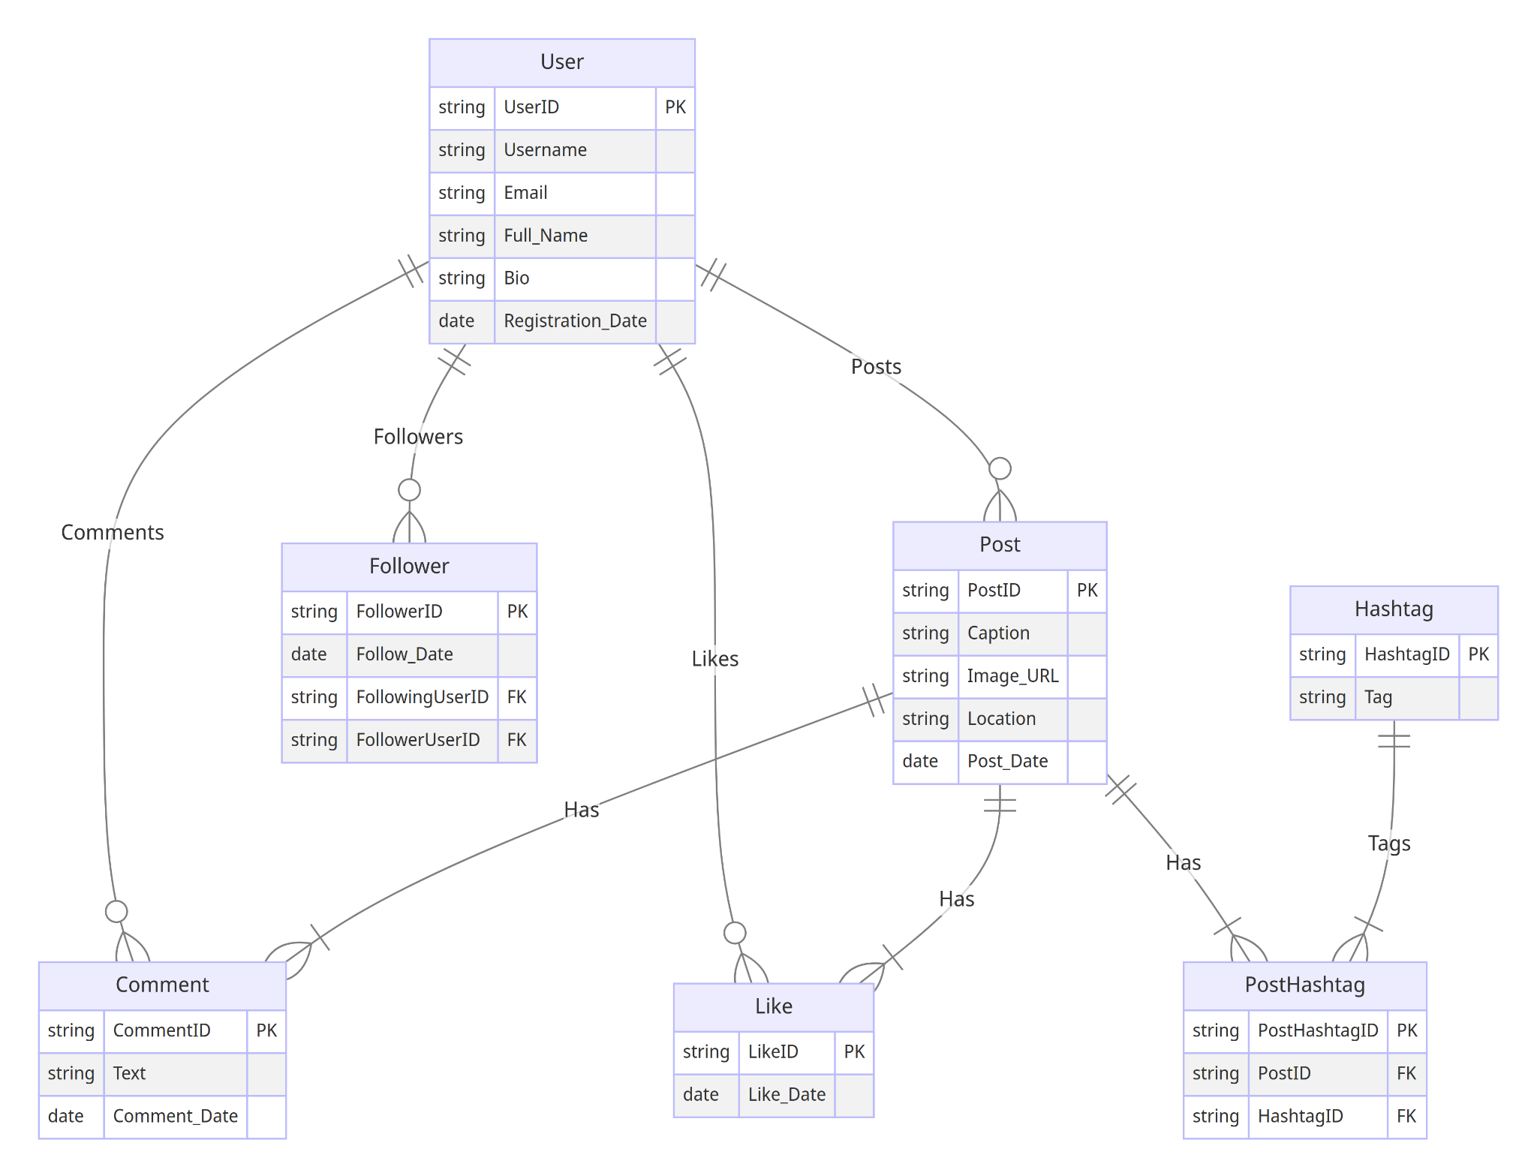

### **Conclusion**

In this case study, we delved into the design of Instagram's schema and Entity-Relationship diagram. Instagram has revolutionised the way people share and engage with visual content, fostering connections and creative expression. The platform's intricate data model, consisting of entities like users, posts, comments, likes, followers, hashtags, and associations, forms the foundation for its seamless functionality. By understanding this schema, we gain insight into how Instagram effectively manages the complexities of user interactions and content sharing, contributing to its widespread popularity and continued growth in the world of social media.